**Lab Practical #06:**

Study the application layer protocol DNS, DHCP, FTP.

**Practical Assignment #06:**

1. **Implement the application layer protocol DNS, DHCP, and FTP. Also check connectivity between them using ping command or PDU utility.**

**Instructions:**

1. Protocol-wise configuration setup screenshot.
2. Mention IP address of each pc as label.
3. Ping command or PDU screenshot between two pcs.
4. **DNS**

**Step-1 :** Build the network topology.

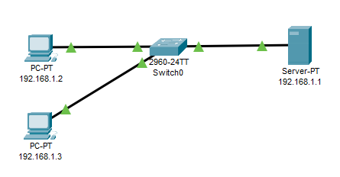

**Step-2:** Configure static IP addresses on the PCs and the server.

Server =>

**IP address**: 192.168.1.1    **Subnet mask**: 255.255.255.0   **Default gateway**: 0.0.0.0   **DNS Server:** 192.168.1.1

PC0 =>

**IP address:**192.168.1.2  **Subnet mask:** 255.255.255.0   **Default gateway:** 0.0.0.0 **DNS server:**192.168.1.1

PC1 =>

**IP address:**192.168.1.3  **Subnet mask:**  255.255.255.0  **Default gateway:**0.0.0.0  **DNS** **Server:** 192.168.1.1

**Step-3:**Configure DNS service on the generic server.

* To do this, click on the server, then Click on Services tab. Click on DNS server from the menu. First turn ON the DNS service, then define names of the hosts and their corresponding IP addresses.
* For example, to specify the DNS entry for PC0: In the name and address fields, type:
* Name: pc0 Address: 192.168.1.2
* Click on add then save.
* Once you’re done, your DNS entries will look like this:

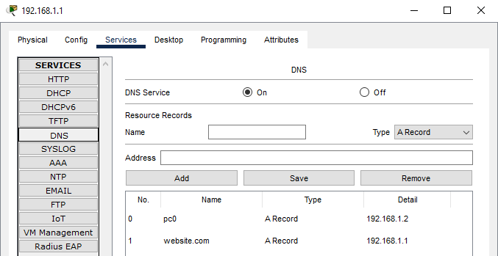

**Step-4:**Go to HTTP and click on index.html => edit

In this file you can over-write whatever you want to showcase in your web page then click on save

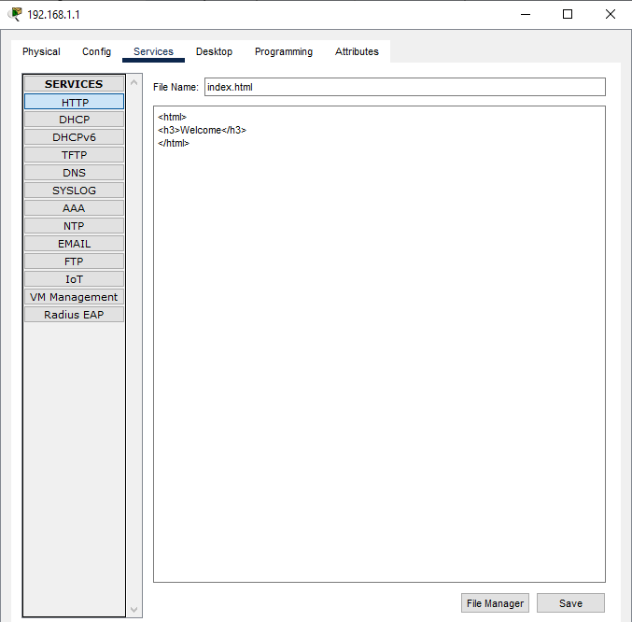

**Step-5:**Now you can go to any pc and check your web page by writing your web page name rather then writing IP address.

PC1(192.168.1.3) >> Desktop >> web browser >> URL

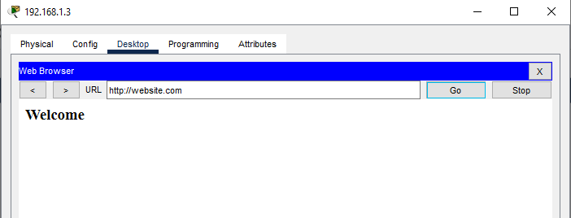

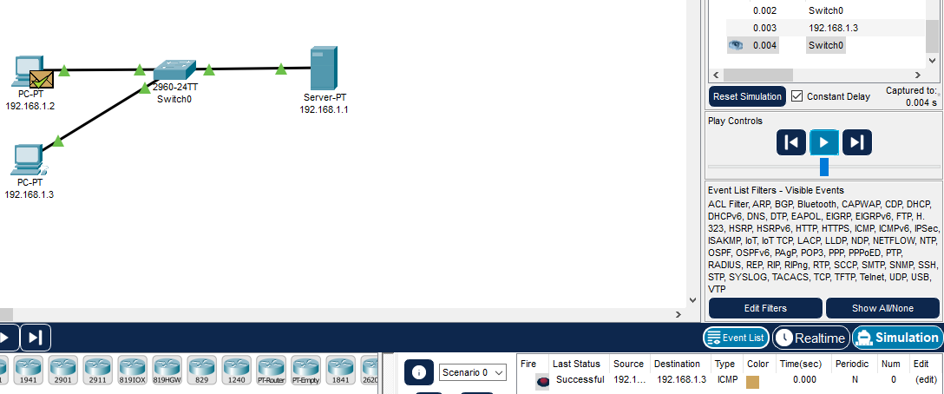

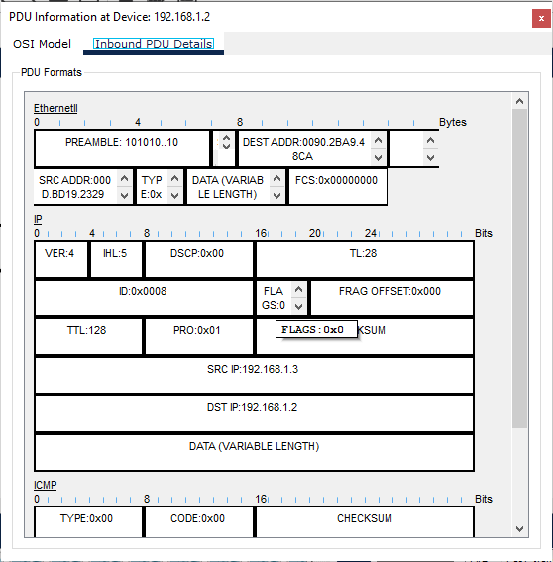

1. **DHCP**

**Step-1:** Build  the network topology in packet tracer.

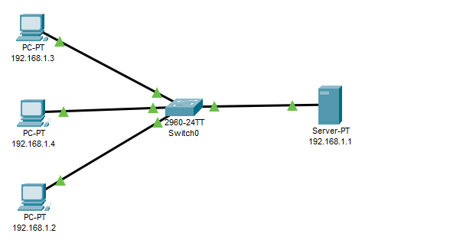

**Step-2:** Configure static IP address on the server 192.168.1.1

**Step-3:** Now configure DHCP service on the generic server.

* Turn **on** the DHCP service.
* To do this, click on the server, then click on Servicestab. You will pick DHCP on the menu. Then proceed to define the DHCP network parameters as follows:
* **Pool name**: serverPool
* **Default Gateway:**192.168.1.0
* **DNS Server:**0.0.0.0
* **Start IP Address:**192.168.1.1
* **Subnet Mask:** 255.255.255.0
* **Maximum Number of users:**255
* Click on add then Save**.** The DHCP entry is included in the list.

Here are the configurations on the server :

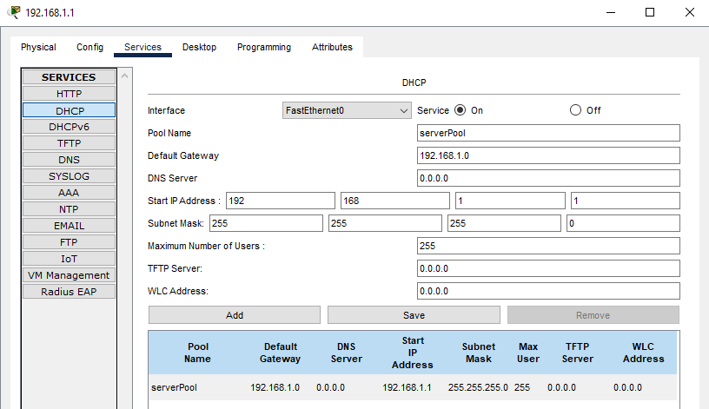

**Step-4:** Finally, enable DHCP configuration on each PC. The three PCs should get automatically configured.

As an example, here is the DHCP configuration on 192.168.1.2 PC :

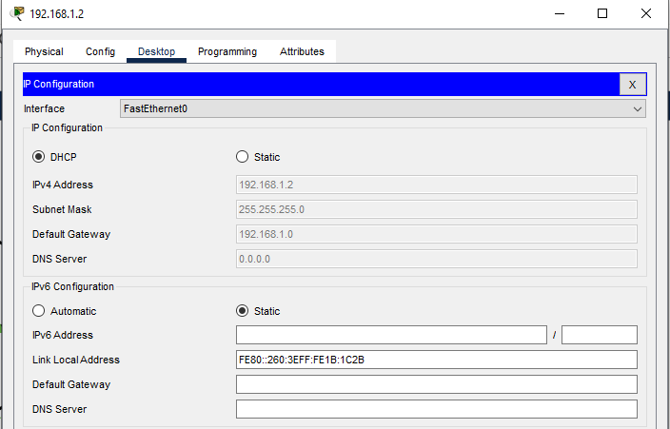

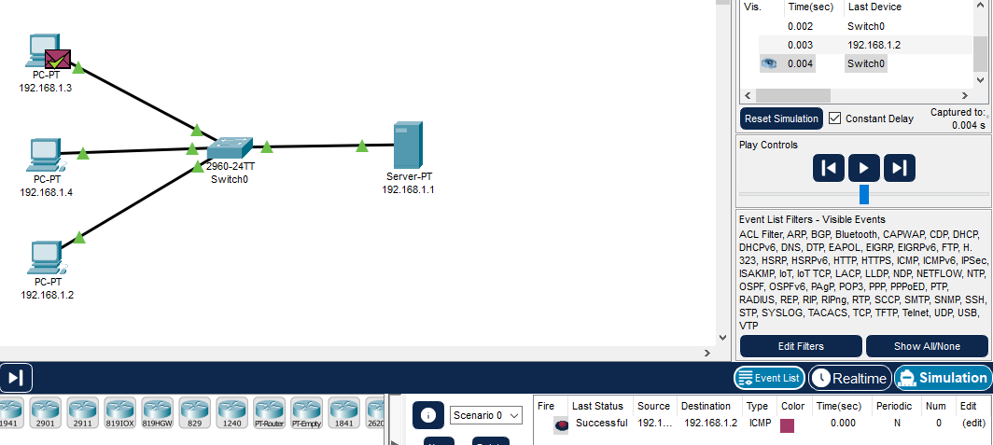

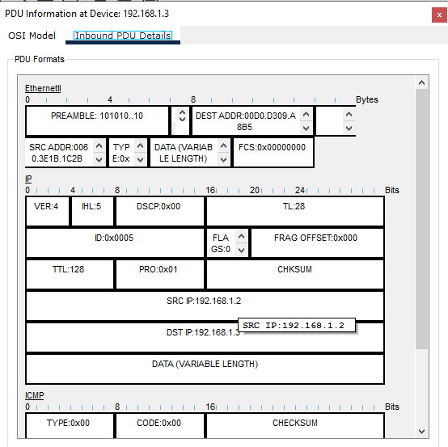

1. **FTP**

**Step-1:** Build  the network topology in packet tracer and config to PC’s.

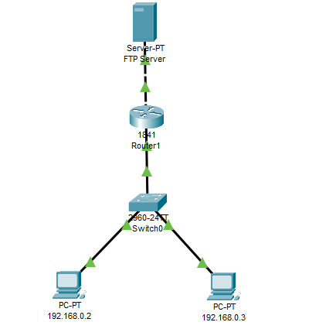

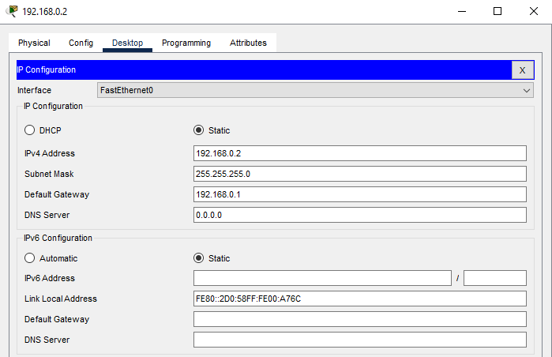

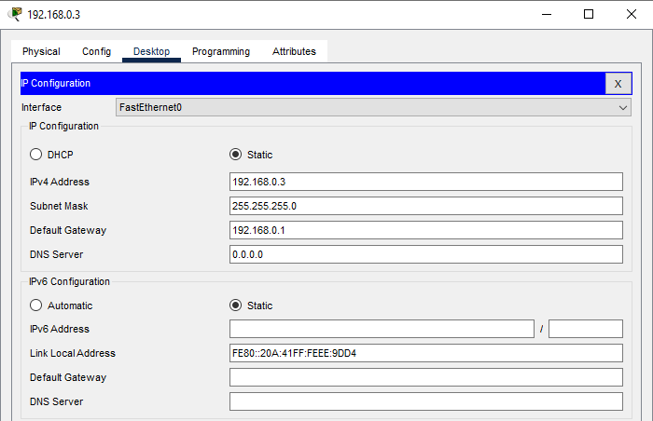

**Step-2:** go to 1841 Router1 => config

* Click on FastEthernet0/0 enable on port then add **IP address:** 10.10.10.1 and **SubnetMask:** 255.0.0.0 again
* Click on FastEtherner0/1 enable on port then add **IP address:** 192.168.0.1 and **SubnetMask:** 255.255.255.0

**Step-3:** configuration of server

* Go to config tab write FTP server in display name if you want to change
* Then click on desktop => ip configuration add

**IP address:** 10.10.10.2

**Subnet Mask:** 255.0.0.0

**Default getway:** 10.10.10.1

**DNS server:** 0.0.0.0

* Go to service tab click on FTP add

Username: cisco1

Password: test

Tick on write, read, rename and click on add button

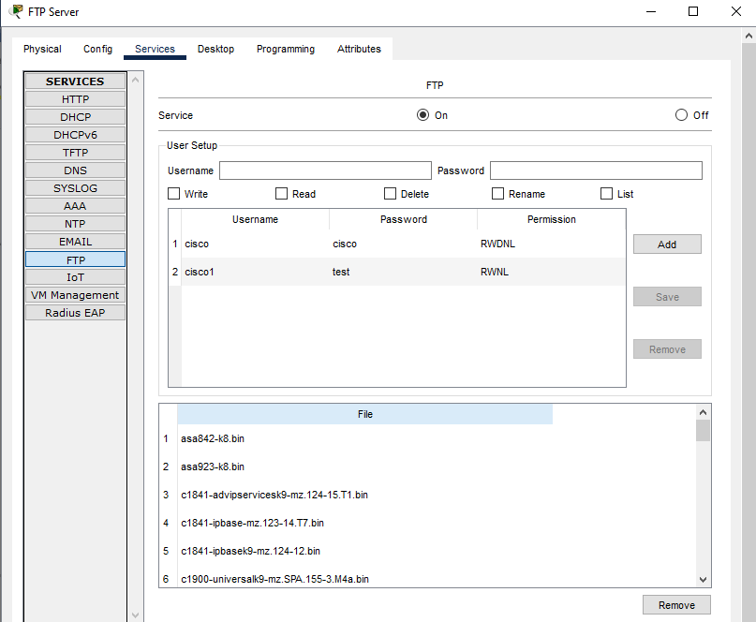

**Step-4:** PC0(192.168.0.2) => desktop => text editor => write something => then click on save

Enter file name => demo

**Step-5:** perform below task

* Write put your-file name

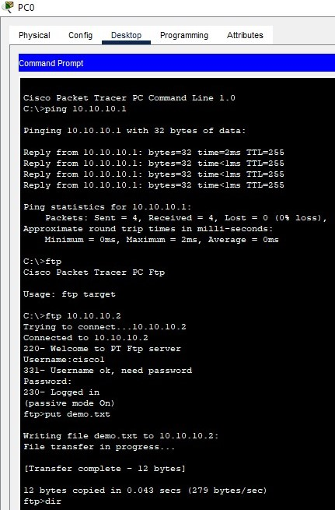

* Write dir

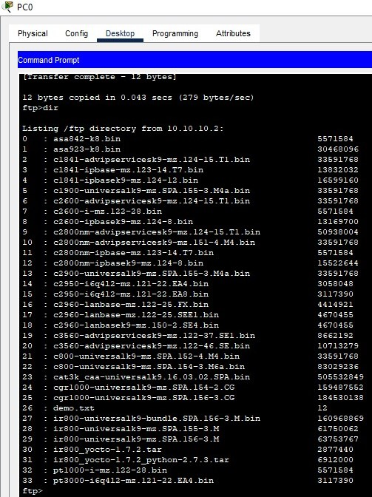

Step-6: go to PC1(192.168.0.3) desktop => command port

* Write get your-filename

